**FORM DESIGN**

**Submitted by,**

**Anju V Thomas**

**MCA LE S3**

**ROLL NO: 14**

1. **LOGIN PAGE**

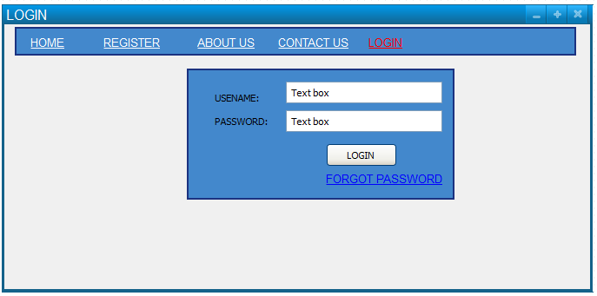

1. **REGISTRATION PAGE**

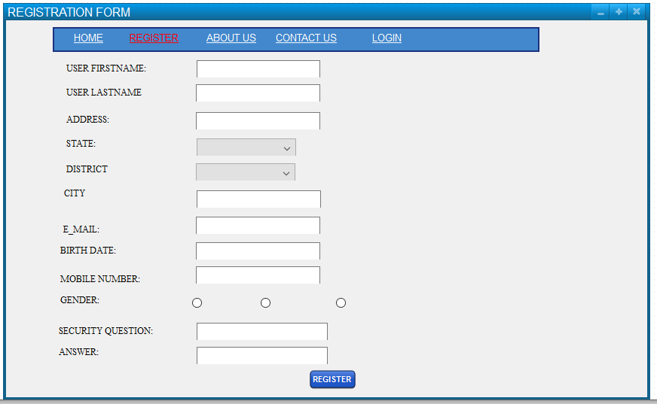

1. **ADDING HOME DETAILS**

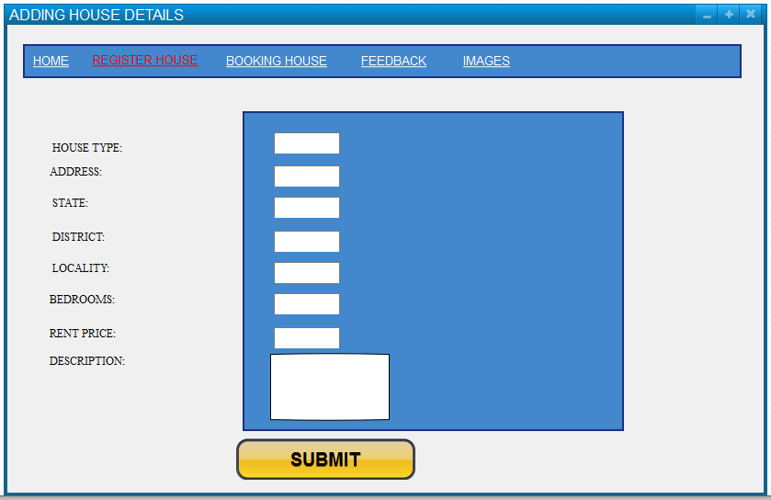

1. **ADDING IMAGES**

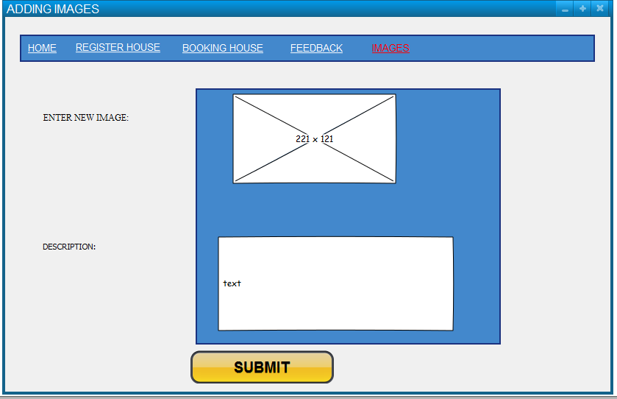

1. **HOME DETAILS**

